Spooner HHSRS2 Scoring Sheet Instructions
*Save workbook in a new folder – I’d recommend something like My Documents/HHSRS Scoring*
Enable Macros when prompted on opening of workbook
This cell has been left unlocked so you can enter in your own council/company logo
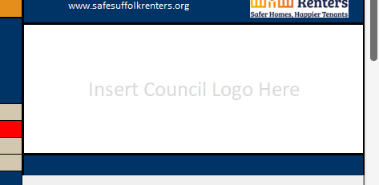
Enter property details – to pull EPC you need at least Property Name/Number and Postcode
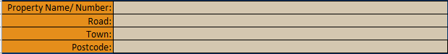
Enter Officer Name, Case Reference, Inspection Date and UPRN – Must have Case Reference entered to ensure data saves and loads correctly for multiple hazards.
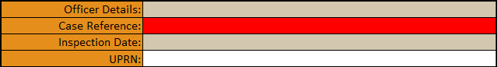
Enter property type from drop down
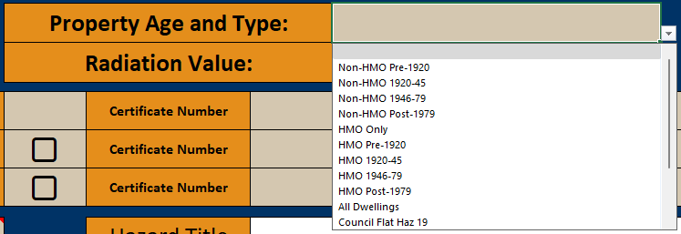
If dealing with Radiation (Hazard 10) select this from the dropdown instead – leave Property Age and Type blank.
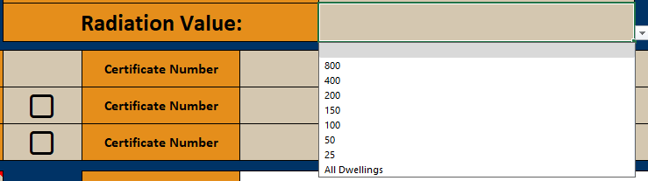

Enter EPC, EICR and Gas Safe details if wanted/needed – If an EPC is entered as F or G it will automatically flag up Red
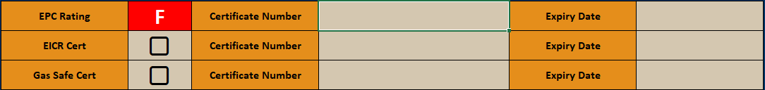
Select Hazard number from the drop down – the note on this cell gives you all the hazards
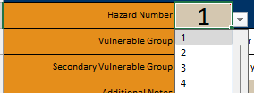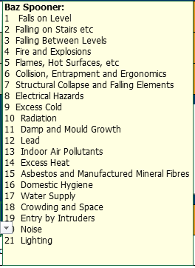
Add any additional notes you may want – Occupiers, etc
Enter Property Description and Hazards (ALT + ENTER is your friend here)
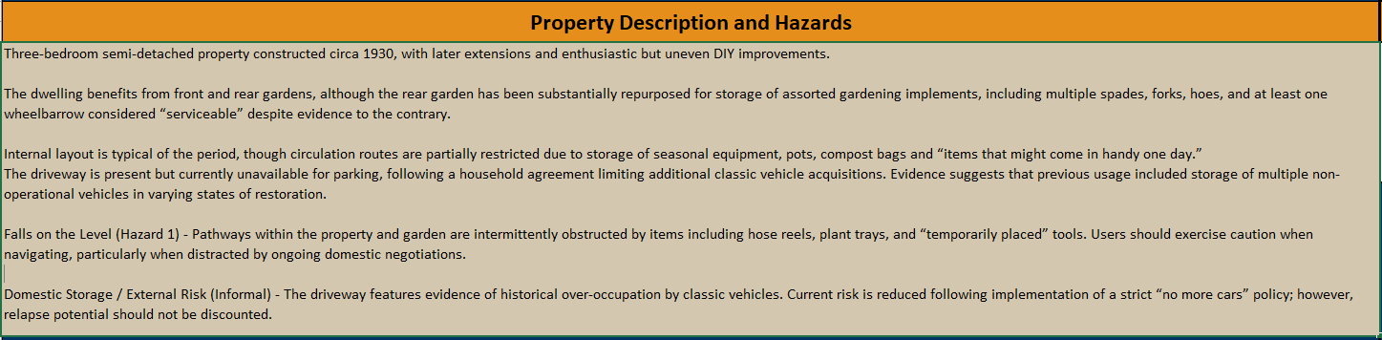
Hyperlinks to Case Studies to be added at a later date
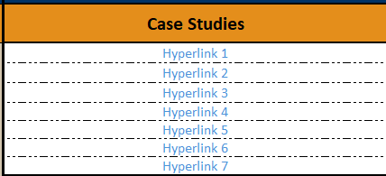
Select if you want “Baseline Indicators” or “Guidance Notes” to be displayed using the drop-down menu. This will automatically import the correct text but will not delete the scoring already input from one to the other.
Enter your scoring in the right-hand beige cells for each indicator, if an incorrect figure is entered into these cells it will flag with a strikeout and black background – NB as explained in the note there may be times when this does not auto size to the indicator. Save your work and restart Excel completely (every open workbook) this allows the coding to restart.
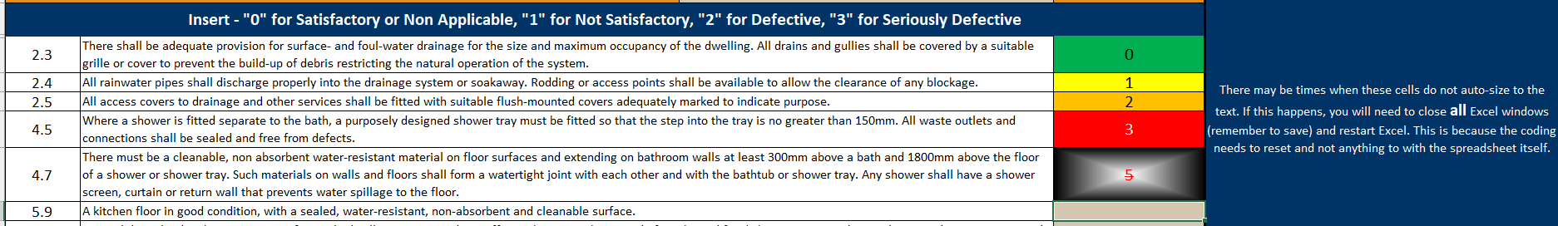
Enter your scoring in the right-hand beige cells for Matters Affecting the Likelihood of harm
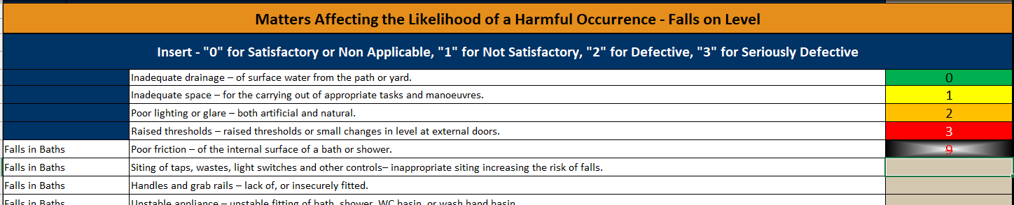
National Average will be auto filled dependant on hazard and property type – Add your Actual Case Likelihood from the drop down menu. Nat. Avg will be purple in the scale below, Case value will be black. If National Average and Case Value are the same, Case Value will take precedent.
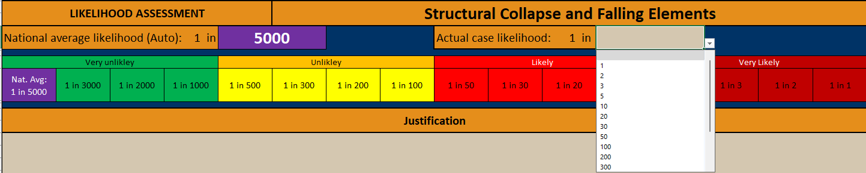
Add your justification for likelihood
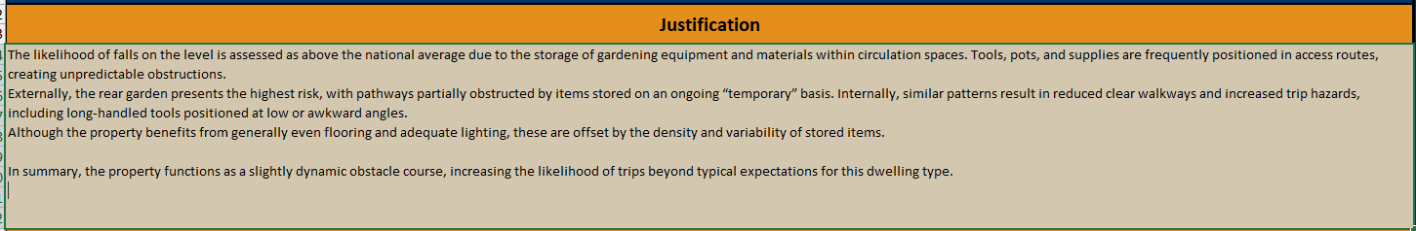
Add your Assessments of Outcomes –
National Averages are auto filled in the first column
Enter your own figures in the beige cells using the drop-down menus
The final cell (usually Moderate) can be selected as “Remainder” from the drop-down, this will automatically total the score up to 100.
Hazard 10 – Radiation: Start at Moderate and work your way up, then use “Remainder” in Extreme.
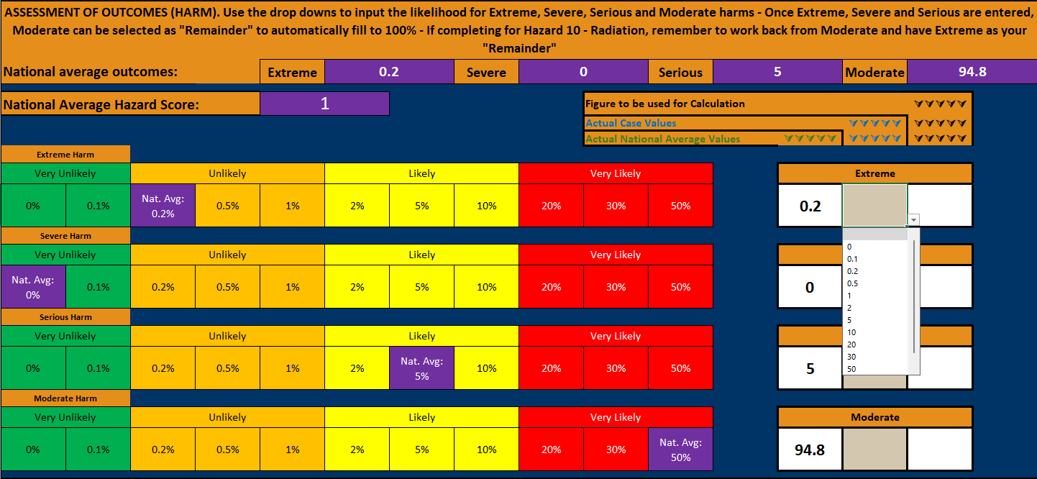
Add your justification – The Hazard Score will now be displayed.
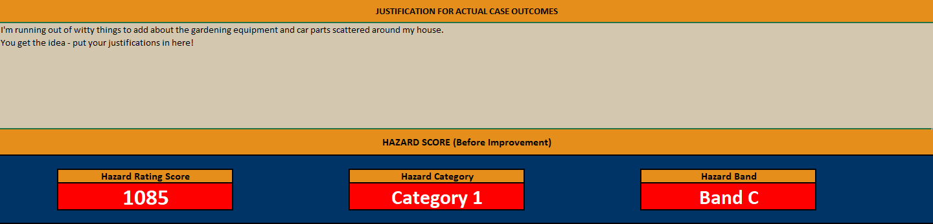
If an improvement is made – 2nd visit. Add the values into New Likelihood, Extreme, Severe, Serious and Moderate (as before using the drop-down menus, Moderate to be selected as “Remainder”) with a justification. A new hazard score will be provided below.
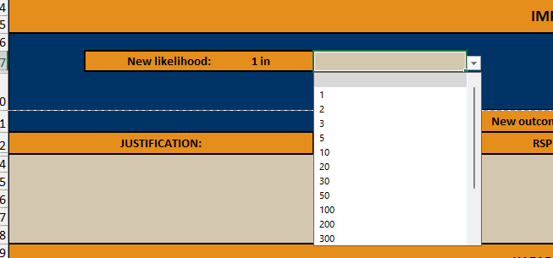
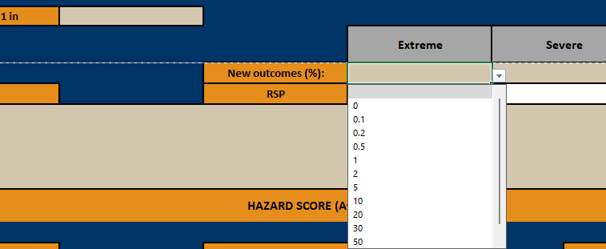
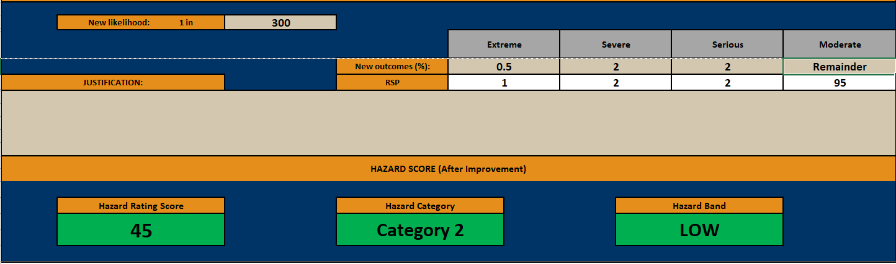
Print To PDF
Near the top of the sheet – highlighted in red below – is a “Print To PDF” button. This is why it is important to save the workbook in a separate folder, as this will Autosave in the same folder.
Once you have completed a hazard scoring, clicking this button will automatically save a PDF of the hazard to update to add to your CRM system (uniform, Assure, etc) but also can be sent to any party linked to the property.
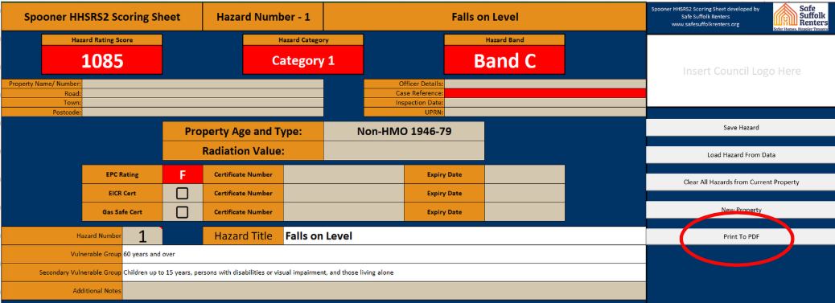
When the button is pressed it will tell you that it is saving the file – Note the save file name is “Spooner HHSRS2 Scoring Sheet Property Name/Number Road Postcode Hazard Number Guidance Note” It will auto pull these from the relevant fields on the workbook (If Baseline Indicators is displaying on the workbook instead of Guideline Notes that will change, giving you the opportunity to save both as separate file names)
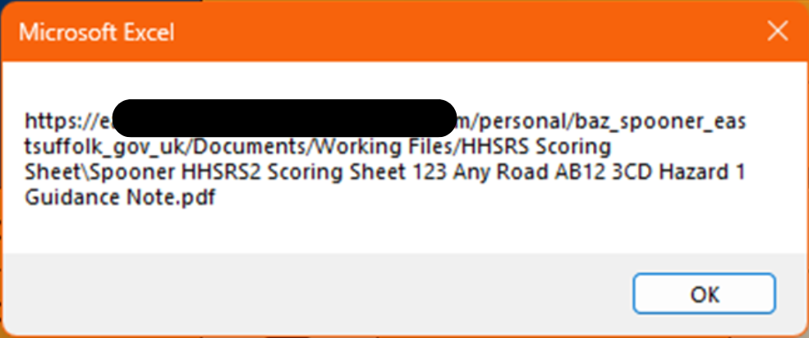
Clicking OK, will bring up another pop-up stating the PDF has been saved.

Adding another hazard to the same property.
Click the “Save Hazard” button.
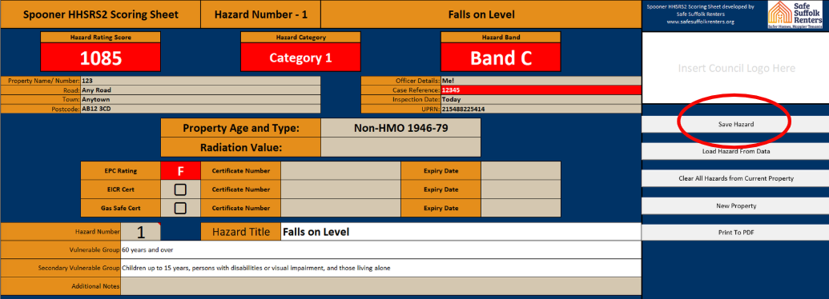
This will bring up a popup stating “Hazard Saved. Form cleared and ready for the next hazard” – Click “OK”
Property Details, Description, Etc will not be removed.
Ensure the case reference is the same – This will not be removed after saving.
Change the hazard number and complete the sheet in the same way as before, once finished click “Save Hazard”
This can be done for every hazard if needed and will be saved for recall later – As long as the case reference is the same.
Load a previous hazard
Ensure that the previous hazard has been saved – This can be checked on the bottom tab “Hazard Data”
Select the Hazard Number you require to be recalled.
Click the “Load Hazard from Data” Button
This will recall all the entered information for said hazard.
Clear all hazards for current property
If you wish to remove all the hazards stored from a property, click on the “Clear All Hazards from Current Property” Button.
A popup will appear:
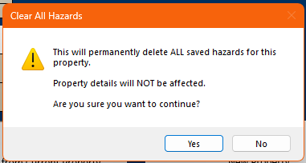
Click “Yes”n if you wish to proceed.
This will as stated removed all the stored Hazard Data, this is not reversible

To start a new property.
I would advise to click “File” and “Save a Copy” – save this as you property address or case number – whichever you prefer.
Click the “New Property” button
Again a warning popup will appear – click “Yes” if you are happy to proceed. This is not reversible
Restart as before.

